Noise Theta 1.0 Sigma 0.2

Episode 1 Average Score: 0.57

Episode 2 Average Score: 0.51

Episode 3 Average Score: 0.39

Episode 4 Average Score: 0.82

Episode 5 Average Score: 0.70

Episode 6 Average Score: 1.23

Episode 7 Average Score: 0.94

Episode 8 Average Score: 0.25

Episode 9 Average Score: 0.91

Episode 10 Average Score: 2.21

Episode 11 Average Score: 0.96

Episode 12 Average Score: 1.04

Episode 13 Average Score: 0.60

Episode 14 Average Score: 0.38

Episode 15 Average Score: 4.28

Episode 16 Average Score: 0.27

Episode 17 Average Score: 0.75

Episode 18 Average Score: 1.10

Episode 19 Average Score: 2.83

Episode 20 Average Score: 1.89

Episode 21 Average Score: 1.44

Episode 22 Average Score: 2.15

Episode 23 Average Score: 3.82

Episode 24 Average Score: 2.48

Episode 25 Average Score: 1.90

Episode 26 Average Score: 2.08

Episode 27 Average Score: 2.49

Episode 28 Average Score: 1.36

Episode 29 Average Score: 2.50

Episode 30 Average Score: 2.29

Episode 31 Average Score: 6.07

Episode 32 Average Score: 4.70

Episode 33 Average Score: 2.17

Episode 34 Average Score: 5.56

Episode 35 Average Score: 4.86

Episode 36 Average Score: 9.05

Episode 37 Average Score: 1.48

Episode 38 Average Score: 2.75

Episode 39 Average Score: 3.35

Episode 40 Average Score: 6.60

Episode 41 Average Score: 8.76

Episode 42 Average Score: 4.91

Episode 43 Average Score: 7.55

Episode 44 Average Score: 2.75

Episode 45 Average Score: 6.72

Episode 46 Average Score: 1.35

Episode 47 Average Score: 5.98

Episode 48 Average Score: 6.99

Episode 49 Average Score: 2.22

Episode 50 Average Score: 1.09

Episode 51 Average Score: 4.82

Episode 52 Average Score: 7.94

Episode 53 Average Score: 4.26

Episode 54 Average Score: 4.94

Episode 55 Average Score: 12.94

Episode 56 Average Score: 10.05

Episode 57 Average Score: 6.99

Episode 58 Average Score: 5.61

Episode 59 Average Score: 0.69

Episode 60 Average Score: 10.29

Episode 61 Average Score: 4.51

Episode 62 Average Score: 4.22

Episode 63 Average Score: 8.09

Episode 64 Average Score: 2.24

Episode 65 Average Score: 7.53

Episode 66 Average Score: 4.72

Episode 67 Average Score: 1.56

Episode 68 Average Score: 3.62

Episode 69 Average Score: 12.00

Episode 70 Average Score: 17.28

Episode 71 Average Score: 10.75

Episode 72 Average Score: 6.58

Episode 73 Average Score: 12.03

Episode 74 Average Score: 11.05

Episode 75 Average Score: 1.26

Episode 76 Average Score: 13.34

Episode 77 Average Score: 10.11

Episode 78 Average Score: 10.53

Episode 79 Average Score: 4.00

Episode 80 Average Score: 13.82

Episode 81 Average Score: 3.87

Episode 82 Average Score: 14.40

Episode 83 Average Score: 11.08

Episode 84 Average Score: 13.50

Episode 85 Average Score: 5.46

Episode 86 Average Score: 16.24

Episode 87 Average Score: 9.11

Episode 88 Average Score: 7.91

Episode 89 Average Score: 21.12

Episode 90 Average Score: 10.29

Episode 91 Average Score: 15.85

Episode 92 Average Score: 1.30

Episode 93 Average Score: 16.62

Episode 94 Average Score: 0.20

Episode 95 Average Score: 13.32

Episode 96 Average Score: 3.40

Episode 97 Average Score: 1.15

Episode 98 Average Score: 18.88

Episode 99 Average Score: 1.57

Episode 100 Average Score: 20.32

Episode 101 Average Score: 7.07

Episode 102 Average Score: 12.84

Episode 103 Average Score: 2.26

Episode 104 Average Score: 1.87

Episode 105 Average Score: 3.08

Episode 106 Average Score: 9.38

Episode 107 Average Score: 6.12

Episode 108 Average Score: 8.08

Episode 109 Average Score: 18.21

Episode 110 Average Score: 21.30

Episode 111 Average Score: 2.04

Episode 112 Average Score: 4.33

Episode 113 Average Score: 2.03

Episode 114 Average Score: 15.66

Episode 115 Average Score: 22.93

Episode 116 Average Score: 7.38

Episode 117 Average Score: 25.93

Episode 118 Average Score: 0.34

Episode 119 Average Score: 11.71

Episode 120 Average Score: 14.99

Episode 121 Average Score: 24.50

Episode 122 Average Score: 4.32

Episode 123 Average Score: 27.10

Episode 124 Average Score: 3.26

Episode 125 Average Score: 28.83

Episode 126 Average Score: 15.27

Episode 127 Average Score: 35.68

Episode 128 Average Score: 9.81

Episode 129 Average Score: 28.86

Episode 130 Average Score: 7.51

Episode 131 Average Score: 24.14

Episode 132 Average Score: 7.54

Episode 133 Average Score: 21.59

Episode 134 Average Score: 2.29

Episode 135 Average Score: 10.12

Episode 136 Average Score: 29.80

Episode 137 Average Score: 7.11

Episode 138 Average Score: 14.47

Episode 139 Average Score: 5.62

Episode 140 Average Score: 34.35

Episode 141 Average Score: 14.56

Episode 142 Average Score: 0.66

Episode 143 Average Score: 38.10

Episode 144 Average Score: 35.35

Episode 145 Average Score: 27.38

Episode 146 Average Score: 21.33

Episode 147 Average Score: 9.89

Episode 148 Average Score: 26.34

Episode 149 Average Score: 36.14

Episode 150 Average Score: 34.94

Episode 151 Average Score: 36.44

Episode 152 Average Score: 5.03

Episode 153 Average Score: 36.90

Episode 154 Average Score: 39.44

Episode 155 Average Score: 2.11

Episode 156 Average Score: 9.45

Episode 157 Average Score: 35.84

Episode 158 Average Score: 39.14

Episode 159 Average Score: 39.63

Episode 160 Average Score: 1.47

Episode 161 Average Score: 37.51

Episode 162 Average Score: 38.27

Episode 163 Average Score: 0.50

Episode 164 Average Score: 38.55

Episode 165 Average Score: 24.03

Episode 166 Average Score: 39.62

Episode 167 Average Score: 39.59

Episode 168 Average Score: 3.82

Episode 169 Average Score: 33.29

Episode 170 Average Score: 37.83

Episode 171 Average Score: 26.50

Episode 172 Average Score: 38.55

Episode 173 Average Score: 6.49

Episode 174 Average Score: 38.88

Episode 175 Average Score: 36.34

Episode 176 Average Score: 37.83

Episode 177 Average Score: 39.60

Episode 178 Average Score: 31.23

Episode 179 Average Score: 28.86

Episode 180 Average Score: 2.86

Episode 181 Average Score: 13.36

Episode 182 Average Score: 29.90

Episode 183 Average Score: 38.21

Episode 184 Average Score: 35.68

Episode 185 Average Score: 30.94

Episode 186 Average Score: 25.28

Episode 187 Average Score: 38.96

Episode 188 Average Score: 35.66

Episode 189 Average Score: 22.70

Episode 190 Average Score: 37.66

Episode 191 Average Score: 14.29

Episode 192 Average Score: 38.06

Episode 193 Average Score: 16.43

Episode 194 Average Score: 31.37

Episode 195 Average Score: 10.59

Episode 196 Average Score: 37.84

Episode 197 Average Score: 38.24

Episode 198 Average Score: 35.59

Episode 199 Average Score: 34.17

Episode 200 Average Score: 34.33

1/272019

20 agents

1000 steps per episode

BUFFER_SIZE = int(1e5) # replay buffer size

BATCH_SIZE = 128 # minibatch size

GAMMA = 0.99 # discount factor

TAU = 1e-3 # for soft update of target parameters

LR_ACTOR = 1e-4 # learning rate of the actor

LR_CRITIC = 1e-3 # learning rate of the critic

WEIGHT_DECAY = 0 # L2 weight decay

UPDATE_RATE = 20 # update frequency

UPDATE_TIMES = 20 # number of updates

Episode 1 Episode Score: 0.35

Episode 2 Average Score: 0.54

Episode 2 Episode Score: 0.54

Episode 3 Average Score: 0.75

Episode 3 Episode Score: 0.75

Episode 4 Average Score: 1.20

Episode 4 Episode Score: 1.20

Episode 5 Average Score: 1.24

Episode 5 Episode Score: 1.24

Episode 6 Average Score: 1.31

Episode 6 Episode Score: 1.31

Episode 7 Average Score: 1.83

Episode 7 Episode Score: 1.83

Episode 8 Average Score: 1.83

Episode 8 Episode Score: 1.83

Episode 9 Average Score: 2.08

Episode 9 Episode Score: 2.08

Episode 10 Average Score: 1.84

Episode 10 Episode Score: 1.84

Episode 11 Average Score: 2.46

Episode 11 Episode Score: 2.46

Episode 12 Average Score: 4.94

Episode 12 Episode Score: 4.94

Episode 13 Average Score: 6.54

Episode 13 Episode Score: 6.54

Episode 14 Average Score: 7.96

Episode 14 Episode Score: 7.96

Episode 15 Average Score: 9.69

Episode 15 Episode Score: 9.69

Episode 16 Average Score: 9.84

Episode 16 Episode Score: 9.84

Episode 17 Average Score: 11.25

Episode 17 Episode Score: 11.25

Episode 18 Average Score: 13.17

Episode 18 Episode Score: 13.17

Episode 19 Average Score: 19.72

Episode 19 Episode Score: 19.72

Episode 20 Average Score: 20.09

Episode 20 Episode Score: 20.09

Episode 21 Average Score: 22.12

Episode 21 Episode Score: 22.12

Episode 22 Average Score: 26.17

Episode 22 Episode Score: 26.17

Episode 23 Average Score: 27.94

Episode 23 Episode Score: 27.94

Episode 24 Average Score: 29.49

Episode 24 Episode Score: 29.49

Episode 25 Average Score: 33.46

Episode 25 Episode Score: 33.46

Episode 26 Average Score: 32.32

Episode 26 Episode Score: 32.32

Episode 27 Average Score: 34.06

Episode 27 Episode Score: 34.06

Episode 28 Average Score: 32.83

Episode 28 Episode Score: 32.83

Episode 29 Average Score: 36.87

Episode 29 Episode Score: 36.87

Episode 30 Average Score: 34.34

Episode 30 Episode Score: 34.34

Episode 31 Average Score: 36.44

Episode 31 Episode Score: 36.44

Episode 32 Average Score: 37.25

Episode 32 Episode Score: 37.25

Episode 33 Average Score: 37.46

Episode 33 Episode Score: 37.46

Episode 34 Average Score: 35.88

Episode 34 Episode Score: 35.88

Episode 35 Average Score: 33.64

Episode 35 Episode Score: 33.64

Episode 36 Average Score: 34.75

Episode 36 Episode Score: 34.75

Episode 37 Average Score: 34.84

Episode 37 Episode Score: 34.84

Episode 38 Average Score: 34.31

Episode 38 Episode Score: 34.31

Episode 39 Average Score: 35.96

Episode 39 Episode Score: 35.96

Episode 40 Average Score: 35.42

Episode 40 Episode Score: 35.42

Episode 41 Average Score: 32.46

Episode 41 Episode Score: 32.46

Episode 42 Average Score: 34.70

Episode 42 Episode Score: 34.70

Episode 43 Average Score: 29.43

Episode 43 Episode Score: 29.43

Episode 44 Average Score: 29.53

Episode 44 Episode Score: 29.53

Episode 45 Average Score: 30.26

Episode 45 Episode Score: 30.26

Episode 46 Average Score: 27.36

Episode 46 Episode Score: 27.36

Episode 47 Average Score: 31.67

Episode 47 Episode Score: 31.67

Episode 48 Average Score: 26.36

Episode 48 Episode Score: 26.36

Episode 49 Average Score: 25.01

Episode 49 Episode Score: 25.01

Episode 50 Average Score: 24.47

Episode 50 Episode Score: 24.47

Episode 51 Average Score: 23.79

Episode 51 Episode Score: 23.79

Episode 52 Average Score: 25.67

Episode 52 Episode Score: 25.67

Episode 53 Average Score: 23.55

Episode 53 Episode Score: 23.55

Episode 54 Average Score: 24.08

Episode 54 Episode Score: 24.08

Episode 55 Average Score: 25.15

Episode 55 Episode Score: 25.15

Episode 56 Average Score: 23.10

Episode 56 Episode Score: 23.10

Episode 57 Average Score: 16.45

Episode 57 Episode Score: 16.45

Episode 58 Average Score: 14.91

Episode 58 Episode Score: 14.91

Episode 59 Average Score: 15.10

Episode 59 Episode Score: 15.10

Episode 60 Average Score: 19.37

Episode 60 Episode Score: 19.37

Episode 61 Average Score: 21.21

Episode 61 Episode Score: 21.21

Episode 62 Average Score: 25.13

Episode 62 Episode Score: 25.13

Episode 63 Average Score: 23.42

Episode 63 Episode Score: 23.42

Episode 64 Average Score: 24.71

Episode 64 Episode Score: 24.71

Episode 65 Average Score: 27.13

Episode 65 Episode Score: 27.13

Episode 66 Average Score: 22.33

Episode 66 Episode Score: 22.33

Episode 67 Average Score: 27.87

Episode 67 Episode Score: 27.87

Episode 68 Average Score: 24.73

Episode 68 Episode Score: 24.73

Episode 69 Average Score: 28.62

Episode 69 Episode Score: 28.62

Episode 70 Average Score: 21.58

Episode 70 Episode Score: 21.58

Episode 71 Average Score: 21.58

Episode 71 Episode Score: 21.58

Episode 72 Average Score: 24.49

Episode 72 Episode Score: 24.49

Episode 73 Average Score: 22.79

Episode 73 Episode Score: 22.79

Episode 74 Average Score: 23.66

Episode 74 Episode Score: 23.66

Episode 75 Average Score: 20.37

Episode 75 Episode Score: 20.37

Episode 76 Average Score: 19.65

Episode 76 Episode Score: 19.65

Episode 77 Average Score: 19.01

Episode 77 Episode Score: 19.01

Episode 78 Average Score: 19.61

Episode 78 Episode Score: 19.61

Episode 79 Average Score: 22.69

Episode 79 Episode Score: 22.69

Episode 80 Average Score: 21.69

Episode 80 Episode Score: 21.69

Episode 81 Average Score: 24.28

Episode 81 Episode Score: 24.28

Episode 82 Average Score: 24.42

Episode 82 Episode Score: 24.42

Episode 83 Average Score: 26.47

Episode 83 Episode Score: 26.47

Episode 84 Average Score: 27.71

Episode 84 Episode Score: 27.71

Episode 85 Average Score: 25.84

Episode 85 Episode Score: 25.84

Episode 86 Average Score: 28.55

Episode 86 Episode Score: 28.55

Episode 87 Average Score: 28.79

Episode 87 Episode Score: 28.79

Episode 88 Average Score: 26.83

Episode 88 Episode Score: 26.83

Episode 89 Average Score: 24.34

Episode 89 Episode Score: 24.34

Episode 90 Average Score: 24.38

Episode 90 Episode Score: 24.38

Episode 91 Average Score: 24.73

Episode 91 Episode Score: 24.73

Episode 92 Average Score: 22.05

Episode 92 Episode Score: 22.05

Episode 93 Average Score: 24.39

Episode 93 Episode Score: 24.39

Episode 94 Average Score: 26.31

Episode 94 Episode Score: 26.31

Episode 95 Average Score: 28.52

Episode 95 Episode Score: 28.52

Episode 96 Average Score: 26.90

Episode 96 Episode Score: 26.90

Episode 97 Average Score: 29.65

Episode 97 Episode Score: 29.65

Episode 98 Average Score: 26.63

Episode 98 Episode Score: 26.63

Episode 99 Average Score: 27.94

Episode 99 Episode Score: 27.94

Episode 100 Average Score: 24.42

Episode 100 Episode Score: 24.42

Episode 101 Average Score: 25.16

Episode 101 Episode Score: 25.16

Episode 102 Average Score: 27.37

Episode 102 Episode Score: 27.37

Episode 103 Average Score: 30.14

Episode 103 Episode Score: 30.14

Episode 104 Average Score: 26.59

Episode 104 Episode Score: 26.59

Episode 105 Average Score: 30.04

Episode 105 Episode Score: 30.04

Episode 106 Average Score: 30.46

Episode 106 Episode Score: 30.46

Episode 107 Average Score: 29.90

Episode 107 Episode Score: 29.90

Episode 108 Average Score: 26.94

Episode 108 Episode Score: 26.94

Episode 109 Average Score: 19.31

Episode 109 Episode Score: 19.31

Episode 110 Average Score: 24.87

Episode 110 Episode Score: 24.87

Episode 111 Average Score: 20.09

Episode 111 Episode Score: 20.09

Episode 112 Average Score: 21.09

Episode 112 Episode Score: 21.09

Episode 113 Average Score: 19.74

Episode 113 Episode Score: 19.74

Episode 114 Average Score: 20.00

Episode 114 Episode Score: 20.00

Episode 115 Average Score: 22.31

Episode 115 Episode Score: 22.31

Episode 116 Average Score: 24.92

Episode 116 Episode Score: 24.92

Episode 117 Average Score: 26.02

Episode 117 Episode Score: 26.02

Episode 118 Average Score: 25.71

Episode 118 Episode Score: 25.71

Episode 119 Average Score: 26.32

Episode 119 Episode Score: 26.32

Episode 120 Average Score: 27.95

Episode 120 Episode Score: 27.95

Episode 121 Average Score: 21.68

Episode 121 Episode Score: 21.68

Episode 122 Average Score: 23.44

Episode 122 Episode Score: 23.44

Episode 123 Average Score: 23.25

Episode 123 Episode Score: 23.25

Episode 124 Average Score: 20.23

Episode 124 Episode Score: 20.23

Episode 125 Average Score: 15.18

Episode 125 Episode Score: 15.18

Episode 126 Average Score: 14.65

Episode 126 Episode Score: 14.65

Episode 127 Average Score: 14.32

Episode 127 Episode Score: 14.32

Episode 128 Average Score: 15.35

Episode 128 Episode Score: 15.35

Episode 129 Average Score: 18.59

Episode 129 Episode Score: 18.59

Episode 130 Average Score: 15.09

Episode 130 Episode Score: 15.09

Episode 131 Average Score: 16.50

Episode 131 Episode Score: 16.50

Episode 132 Average Score: 17.64

Episode 132 Episode Score: 17.64

Episode 133 Average Score: 19.13

Episode 133 Episode Score: 19.13

Episode 134 Average Score: 22.81

Episode 134 Episode Score: 22.81

Episode 135 Average Score: 23.00

Episode 135 Episode Score: 23.00

Episode 136 Average Score: 23.77

Episode 136 Episode Score: 23.77

Episode 137 Average Score: 30.38

Episode 137 Episode Score: 30.38

Episode 138 Average Score: 27.65

Episode 138 Episode Score: 27.65

Episode 139 Average Score: 25.16

Episode 139 Episode Score: 25.16

Episode 140 Average Score: 29.48

Episode 140 Episode Score: 29.48

Episode 141 Average Score: 25.67

Episode 141 Episode Score: 25.67

Episode 142 Average Score: 24.05

Episode 142 Episode Score: 24.05

Episode 143 Average Score: 22.31

Episode 143 Episode Score: 22.31

Episode 144 Average Score: 20.88

Episode 144 Episode Score: 20.88

Episode 145 Average Score: 23.29

Episode 145 Episode Score: 23.29

Episode 146 Average Score: 21.97

Episode 146 Episode Score: 21.97

Episode 147 Average Score: 16.86

Episode 147 Episode Score: 16.86

Episode 148 Average Score: 22.47

Episode 148 Episode Score: 22.47

Episode 149 Average Score: 18.11

Episode 149 Episode Score: 18.11

Episode 150 Average Score: 15.24

Episode 150 Episode Score: 15.24

Episode 151 Average Score: 19.62

Episode 151 Episode Score: 19.62

Episode 152 Average Score: 16.03

Episode 152 Episode Score: 16.03

Episode 153 Average Score: 18.74

Episode 153 Episode Score: 18.74

Episode 154 Average Score: 18.97

Episode 154 Episode Score: 18.97

Episode 155 Average Score: 20.20

Episode 155 Episode Score: 20.20

Episode 156 Average Score: 22.26

Episode 156 Episode Score: 22.26

Episode 157 Average Score: 23.92

Episode 157 Episode Score: 23.92

Episode 158 Average Score: 23.42

Episode 158 Episode Score: 23.42

Episode 159 Average Score: 23.41

Episode 159 Episode Score: 23.41

Episode 160 Average Score: 21.93

Episode 160 Episode Score: 21.93

Episode 161 Average Score: 26.17

Episode 161 Episode Score: 26.17

Episode 162 Average Score: 27.07

Episode 162 Episode Score: 27.07

Episode 163 Average Score: 24.76

Episode 163 Episode Score: 24.76

Episode 164 Average Score: 28.81

Episode 164 Episode Score: 28.81

Episode 165 Average Score: 25.43

Episode 165 Episode Score: 25.43

Episode 166 Average Score: 30.10

Episode 166 Episode Score: 30.10

Episode 167 Average Score: 28.11

Episode 167 Episode Score: 28.11

Episode 168 Average Score: 28.19

Episode 168 Episode Score: 28.19

Episode 169 Average Score: 23.02

Episode 169 Episode Score: 23.02

Episode 170 Average Score: 24.32

Episode 170 Episode Score: 24.32

Episode 171 Average Score: 21.21

Episode 171 Episode Score: 21.21

Episode 172 Average Score: 24.86

Episode 172 Episode Score: 24.86

Episode 173 Average Score: 25.88

Episode 173 Episode Score: 25.88

Episode 174 Average Score: 27.01

Episode 174 Episode Score: 27.01

Episode 175 Average Score: 26.97

Episode 175 Episode Score: 26.97

Episode 176 Average Score: 26.18

Episode 176 Episode Score: 26.18

Episode 177 Average Score: 28.64

Episode 177 Episode Score: 28.64

Episode 178 Average Score: 34.42

Episode 178 Episode Score: 34.42

Episode 179 Average Score: 34.20

Episode 179 Episode Score: 34.20

Episode 180 Average Score: 34.31

Episode 180 Episode Score: 34.31

Episode 181 Average Score: 34.98

Episode 181 Episode Score: 34.98

Episode 182 Average Score: 31.16

Episode 182 Episode Score: 31.16

Episode 183 Average Score: 30.42

Episode 183 Episode Score: 30.42

Episode 184 Average Score: 27.66

Episode 184 Episode Score: 27.66

Episode 185 Average Score: 32.42

Episode 185 Episode Score: 32.42

Episode 186 Average Score: 31.90

Episode 186 Episode Score: 31.90

Episode 187 Average Score: 30.12

Episode 187 Episode Score: 30.12

Episode 188 Average Score: 30.87

Episode 188 Episode Score: 30.87

Episode 189 Average Score: 27.52

Episode 189 Episode Score: 27.52

Episode 190 Average Score: 29.58

Episode 190 Episode Score: 29.58

Episode 191 Average Score: 23.59

Episode 191 Episode Score: 23.59

Episode 192 Average Score: 28.03

Episode 192 Episode Score: 28.03

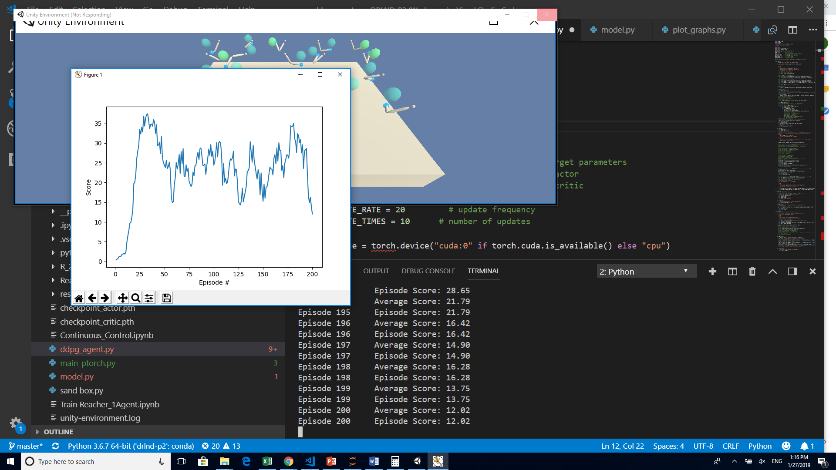

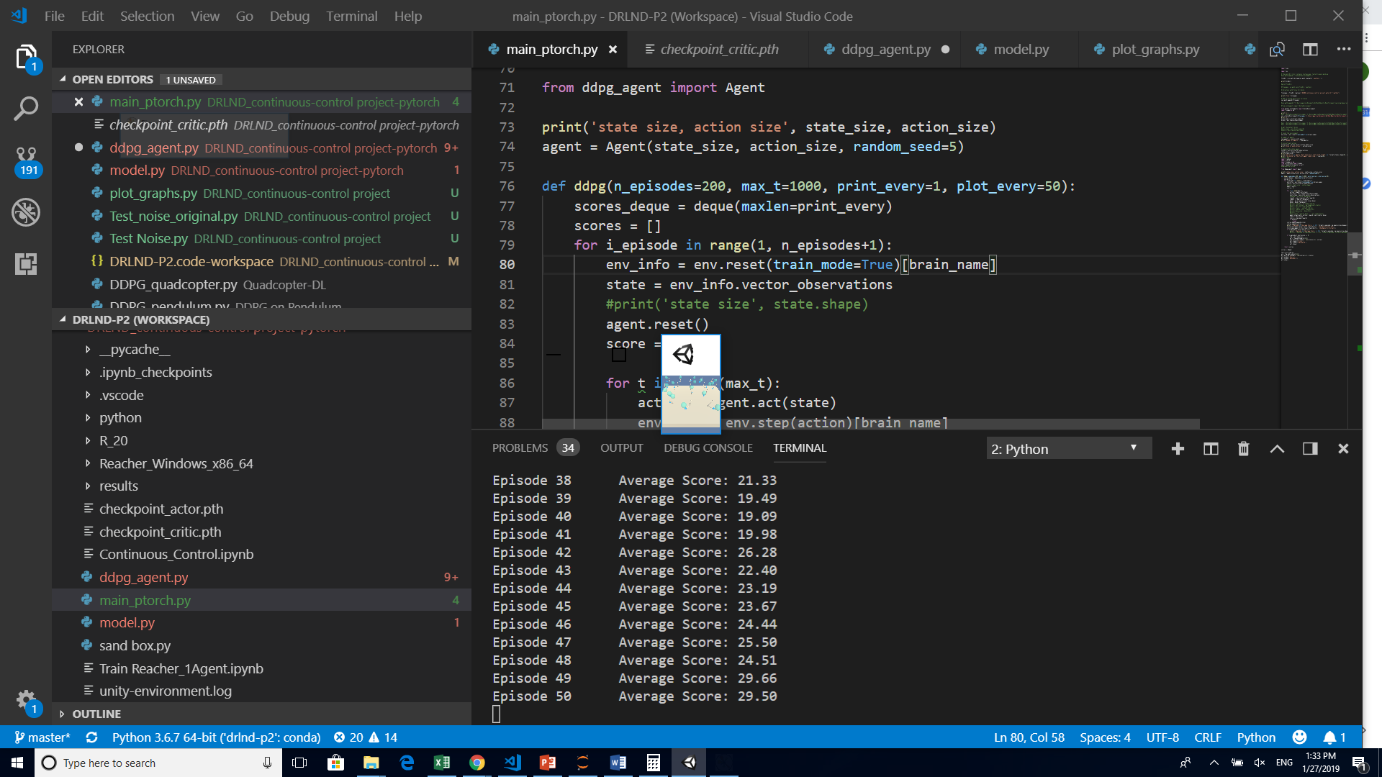

Experiment #3

Update 10 times every 20 steps

Change clipping function to non- deprecated

torch.nn.utils.clip_grad_norm_(self.critic_local.parameters(), 1)

BUFFER_SIZE = int(1e5) # replay buffer size

BATCH_SIZE = 128 # minibatch size

GAMMA = 0.99 # discount factor

TAU = 1e-3 # for soft update of target parameters

LR_ACTOR = 1e-4 # learning rate of the actor

LR_CRITIC = 1e-3 # learning rate of the critic

WEIGHT_DECAY = 0 # L2 weight decay

UPDATE_RATE = 20 # update frequency

UPDATE_TIMES = 10 # number of updates

Episode 1 Average Score: 0.30

Episode 2 Average Score: 0.51

Episode 3 Average Score: 0.62

Episode 4 Average Score: 0.65

Episode 5 Average Score: 0.61

Episode 6 Average Score: 0.82

Episode 7 Average Score: 1.07

Episode 8 Average Score: 1.39

Episode 9 Average Score: 1.15

Episode 10 Average Score: 1.20

Episode 11 Average Score: 1.26

Episode 12 Average Score: 1.45

Episode 13 Average Score: 1.85

Episode 14 Average Score: 2.84

Episode 15 Average Score: 2.47

Episode 16 Average Score: 2.59

Episode 17 Average Score: 3.24

Episode 18 Average Score: 4.10

Episode 19 Average Score: 4.22

Episode 20 Average Score: 3.62

Episode 21 Average Score: 4.94

Episode 22 Average Score: 5.27

Episode 23 Average Score: 6.84

Episode 24 Average Score: 6.98

Episode 25 Average Score: 7.44

Episode 26 Average Score: 8.98

Episode 27 Average Score: 8.29

Episode 28 Average Score: 8.21

Episode 29 Average Score: 11.63

Episode 30 Average Score: 12.67

Episode 31 Average Score: 14.24

Episode 32 Average Score: 16.96

Episode 33 Average Score: 14.57

Episode 34 Average Score: 16.40

Episode 35 Average Score: 15.99

Episode 36 Average Score: 14.15

Episode 37 Average Score: 17.77

Episode 38 Average Score: 21.33

Episode 39 Average Score: 19.49

Episode 40 Average Score: 19.09

Episode 41 Average Score: 19.98

Episode 42 Average Score: 26.28

Episode 43 Average Score: 22.40

Episode 44 Average Score: 23.19

Episode 45 Average Score: 23.67

Episode 46 Average Score: 24.44

Episode 47 Average Score: 25.50

Episode 48 Average Score: 24.51

Episode 49 Average Score: 29.66

Episode 50 Average Score: 29.50

Episode 51 Average Score: 31.44

Episode 52 Average Score: 27.98

Episode 53 Average Score: 30.20

Episode 54 Average Score: 32.09

Episode 55 Average Score: 29.57

Episode 56 Average Score: 31.71

Episode 57 Average Score: 26.74

Episode 58 Average Score: 27.29

Episode 59 Average Score: 25.66

Episode 60 Average Score: 31.46

Episode 61 Average Score: 34.61

Episode 62 Average Score: 33.35

Episode 63 Average Score: 30.93

Episode 64 Average Score: 26.29

Episode 65 Average Score: 29.94

Episode 66 Average Score: 30.69

Episode 67 Average Score: 31.56

Episode 68 Average Score: 27.91

Episode 69 Average Score: 26.44

Episode 70 Average Score: 24.57

Episode 71 Average Score: 18.12

Episode 72 Average Score: 14.83

Episode 73 Average Score: 13.12

Episode 74 Average Score: 16.95

Episode 75 Average Score: 15.05

Episode 76 Average Score: 19.28

Episode 77 Average Score: 15.69

Episode 78 Average Score: 21.18

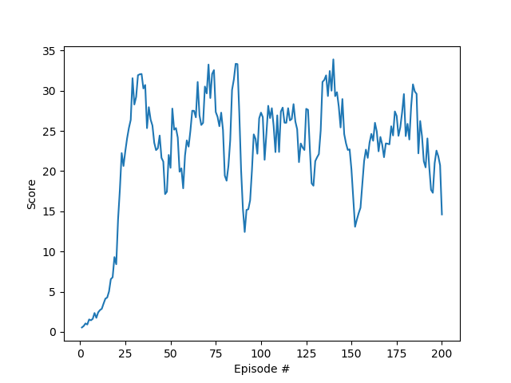

Experiment #4

Increased buffer and batch. INcreased learning rate for actor

BUFFER_SIZE = int(1e6) # replay buffer size

BATCH_SIZE = 256 # minibatch size

GAMMA = 0.99 # discount factor

TAU = 1e-3 # for soft update of target parameters

LR_ACTOR = 1e-3 # learning rate of the actor

LR_CRITIC = 1e-3 # learning rate of the critic

WEIGHT_DECAY = 0 # L2 weight decay

UPDATE_RATE = 20 # update frequency

UPDATE_TIMES = 20 # number of updates

Changed noise to Theta = 0.15. Sigma = 0.2

Eliminated batch normalization for layers other than first on both critic and network

See <https://github.com/kinwo/deeprl-continuous-control/blob/master/model.py> for example implementation from blog

<https://medium.com/@kinwo/solving-continuous-control-environment-using-deep-deterministic-policy-gradient-ddpg-agent-5e94f82f366d>